Automated Invoice Approval Processing

| July-20 |

**Document Overview**

**Documentation Goals**

This documentation is intended to provide instruction for ***Automated Invoice Approval Processing****.*

**Documentation Disclaimers**

* Teach a user how to automatically process multiple invoices without having to individually process them manually.
* Provide instructions for setting up invoices for automated approval.
* Provide explanations for any automation errors if and when processing fails.

**Table of Contents**

**Overview of Advantzware Specific Keys and Icons** 3

Function Keys 3

Advanced Software Standard Function Keys 4

Program Icons 5

**Business Case** 6

**Overview of Invoice Processing Changes** 7

Auto Approval Procedure 7

Invoice Verification 8

Approval Failure Tag 8

Approval Column 8

Invoice Export 9

Invoice Tag View 9

Invoice Filtering 10

Invoice Register 11

Posting Invoices 11

# **Overview of Advantzware Specific Keys and Icons**

## Function Keys

|  |  |
| --- | --- |
| BRWS | The browser, which is a list of records in this file. This is functionally equivalent to the Find option of our standard package. |
| VIEW | View record provides the ability to ADD, CHANGE, DELETE, and UPDATE an individual record. |
| SORT BY | The selections at the bottom of the browser, which will sort the list alphabetic order. |
|  |  |
| Update | Update the current record. |
| Reset | Reset the current record. |
| Add | Add a record. |
| Copy | This will copy the existing record. |
| Delete | Delete the current record displayed on the screen. |
| Cancel | Cancel the information that was entered. |
| Save | Save the record. |
|  |  |
|  | Takes the user to the first current record. |
|  | Moves backward one record. |
|  | Moves forward one record. |
|  | Takes the user to the last current record. |
|  |  |
| F1 | Miscellaneous Fields |
| F3 | Search |
| F3 | List |
| F4 | Notes |
| F6 | Browse |
| F7 | Viewer |
| F12 | Exit |

## Advanced Software Standard Function Keys

|  |  |
| --- | --- |
| Next | Shows the next sequential record. |
| Prev | Shows the previous record. |
| Add | Add a record. |
| Change | Change the current record displayed on the screen. |
| Delete | Delete the current record displayed on the screen. |
| Find | Find a record by searching by description. |
| “1”, “2” | Number 1 or 2 to go the first or second page of this record. |
| Esc | Escape from the current transaction without updating. |
| Q | Quit from the current transaction without updating. |
| F1 | Save |
| F3 | Help information is available on every data field. Simply place the cursor on a field and press F3 to display documentation regarding this particular field. |
| F3 | To insert additional data in a data field without erasing the information currently displayed. |
| F4 | Notes – General |
| F1 | Field Lookup is available on every data field which is maintained in a separate file. Place the cursor on a field and press ***“F1”*** to search for the code by description or to advance a screen of records by pressing the next key. Place the cursor next to the desired record and press enter to transfer the record to the data entry screen. See ***“Page Up”*** / ***“Page Down”*** keys below as an alternative |
| F7 | Delete |
| F8 | Notes – File Specific |
| Enter | Advances the cursor to the next field |
| Page Up | Will skim forward through each record in a data file in sequential order |
| Page Down | Will skim backward through each record in a data file in sequential order |
|  |  |

## Program Icons

|  |  |  |
| --- | --- | --- |
|  | Job Notes |  |
|  | Customer Attachments | Attach files (such as Word/Excel/Images) for this specific customer order. |
|  | Change Move/Set Column Mode |  |
|  | Print Acknowledgement |  |
|  | Export to Excel |  |
|  | Add |  |
|  | Attachments | Attachments for this Estimate. Will transfer to all future repeat orders for this estimate. |
|  | Notes |  |
|  | Spec Notes | Notes for specific finished goods items. |
|  | Utility Application |  |
|  | Help |  |
|  | UDF Viewer |  |
|  | Commissions |  |
|  | Exit |  |
|  |  |  |
|  |  |  |

# **Business Case**

Invoices are created when Bill of Ladings’ are posted, and many times these do not need to be reviewed and could be processed automatically. The automatic invoice approval process is currently contained in a self-contained procedure that can be placed in any program desired and is expected to be included in the post BOL program.

However, there are some concerns associated with the automation steps and process involved here. In the current version, this procedure has been placed in ***“O”-“B”-“1”*** as an icon on the top left titled ‘***Check’*** for manual execution of all the functionality with the user able to enter a range of dates, customers and invoice numbers.

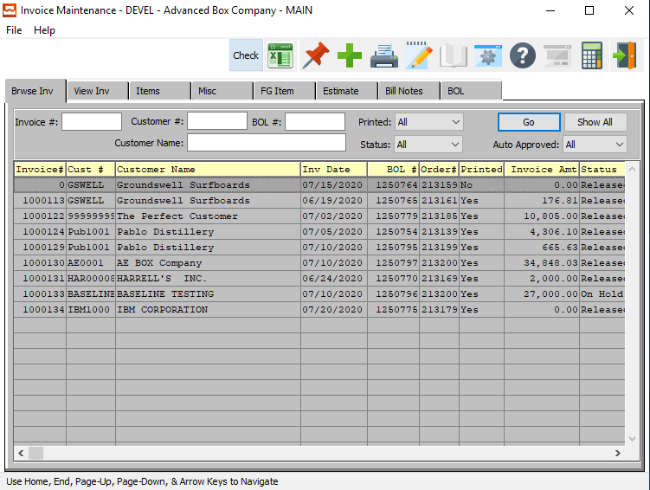



# **Overview of Invoice Processing Changes**

## Auto Approval Procedure

The system has a new button titled ‘***Check’*** in ***“O”-“B”-“1”*** that will result in the approval of all invoices that meet the criteria to be auto approved. These invoices will be validated and flagged as automatically approved without intervention if all validation cases are passed.

The approval process will use the following validations for each invoice and if any of these fail processing then the invoice will not be approved and the list of reasons the invoice failed approval will be reported back on each invoice.

#### Customer is Valid

Verifies that the customer is a valid customer as defined in the customer file and if the customer is not valid, the approval process cannot proceed with this invoice and it will be skipped. This will not occur in normal processing of invoices.

#### General Ledger Account Verification

This validation looks at the invoice and verifies that the general ledger account numbers are valid for all items related to the invoice. If the account numbers are not valid, they fall back to the default values from ***“A”-“F”-“7”*** but those accounts must be valid. If not valid, then the invoice will not be approved.

#### Data Verification Locations

|  |  |  |
| --- | --- | --- |
| ***Data*** | ***Location*** | ***Hotkey Sequence*** |
| Customer A/R Class | From customer file is linked to A/R Class | ***“A” – “F” – “9”*** |
| Sales Account | From each FG Item linked to the product line | ***“J” – “F” – “3”*** |
| COGS Accounts | From the FG Item linked to the product line | ***“J” – “F” – “3”*** |
| Sales Tax Accounts | From the Sales tax code on invoice linked to tax file | ***“A” – “F” – “6”*** |
| Freight | From the A/R control (If not a misc. invoice line | ***“A” – “F” – “7”*** |
| Discounts | From the A/R control file | ***“A” – “F” – “7”*** |
| Cash Account | From A/R control for cash terms invoices | ***“A” – “F” – “7”*** |
| Sales Tax Code | It not set, will default to the sales tax code | ***“A” – “F” – “7”*** |
| WIP Accounts* | From the FG Item linked to the product line | ***“J” – “F” – “3”*** |

* Please Note: If any of the 4 categories of costs or WIP are not defined, the Discount Account is used by default (See Discount account in ***“A” – “F” – “7”***). If not set, normally the WIP and COGS values will offset and net to zero.

### Invoice Verification

This validation looks at the invoice lines and verifies that the line item and processes each line item and the invoice as a whole. These are of two categories – Critical Rule / Business Rule:

#### Critical Rule

The following data must be corrected before the invoice can be processed:

|  |  |
| --- | --- |
| A/R Control | Verifies the company has a valid A/R control file |
| Currency Valid | Currency code is valid |
| FG Item Number | Verifies that the item number is valid |
| In Balance | Verifies the invoice is balanced (Lines, totals, account number balances) |
| Invoice Header | Verifies invoice header exists |
| Item Cost | Verifies that the item cost is not zero (If ***“N”-“K”-“1”*** = InvPost is set) |
| Misc. Line Item | Valid G/L account exists on the Misc. item |
| Output Path | Verifies the path for output of results is valid |
| Period | Verifies the accounting period is valid |
| Product Line | Verifies product line exists |

#### Business Rule

The following data is informational and will not prevent processing an invoice.

|  |  |
| --- | --- |
| Bill Notes | Verifies there are no billing notes for the invoice |
| Freight Amount | If freight is billable, that freight amount is not zero |
| Freight Terms | Verify that the freight terms are valid |
| Price > Cost | Verifies that the price of the item is greater than the cost of the item |
| Status | Invoice status is not on Hold (Invoices on Hold are skipped) |
| Taxable | Verifies that if the ship to is taxable and any line is not set as taxable |

### Approval Failure Tag

If any of the validations do not pass, then the invoice will get tags with the appropriate reason that the invoice was not approved. This allows the billing personnel to review those invoices and verify that the invoice should be processed. They can then manually correct the given problem, and run the approval again to validate and process the corrected invoice.

### Approval Column

The view of invoices displays the Auto Approved status in the column called ‘*Auto’* with either a *‘Yes’* or a *‘No’* value.

If the column has a ‘*Yes’,* then the invoice has been auto approved and passed all the validations for the invoice. If any of the validations fail, then the invoice will set this column to *‘No’*, which indicates that there is a problem with the invoice, and that it needs attention.

### Invoice Export

|  |  |
| --- | --- |
|  | The invoice export (“***Excel Icon”***) will export the invoices, and the option exists to include the ‘*Auto’* flag as well as the tags of reasons that the invoice did not get approved. This is helpful when processing a large quantity of invoices to see all of the unapproved invoices and reasons. |

### Invoice Tag View

#### Auto-Approved

The invoice view will display the ‘Auto-Approval’ when the invoice passes all the validations for an invoice and it is ready to process. The user can easily see if an invoice has been auto-approved, as the *‘Auto-Approved’* toggle box will be checked.



#### Not Approved

If the validation fails for any reason, then the reason(s) will be displayed for the user to review and correct. Each reason will create a separate tag indicating the issue, the line or item number that is causing the problem.

The user can easily see if an invoice has been auto-approved, as the *‘Auto-Approved’* toggle box will remain unchecked.



#### Validation Display

Clicking on the ***‘?’*** button will open the *‘Tag* Viewer’ popup window to display the validations that did not pass the approval process. Each of these just mean the auto approval could not pass the invoice. Some of these are reasons that must be cleared, and others are for information only.

These reasons can be reviewed and dealt with by the billing team. See the validations above to see which will prevent processing the invoice above.

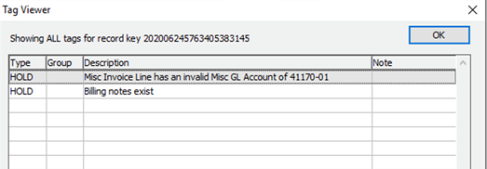

### Invoice Filtering

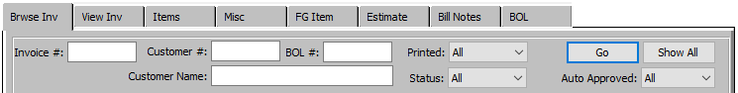

The filtering of invoices allows quick views of the status of invoices that meet certain criteria.

#### Auto Approved

This indicates if the invoice was auto approved or not. Valid options include ‘*All’*, ‘*Yes’* or ‘No’.

This flag is set once the invoice is approved and passes all validation which sets the auto approval flag on the invoice. An invoice does not need to be auto approved to be printed, or before it can be posted, so whether auto approved or not will not impact the posting process.

#### Bill of Lading Number

This filter is for BOL number. (This is numeric, so the entire invoice number must match.)

#### Customer

This can either be a partial or exact match to filter by customer.

#### Customer Name

This is a ‘*Starts With*’ and looks for a customer name that starts or begins with what is entered.

#### Invoice Number

This allows a filter for a specific invoice number. (This is numeric, so entire invoice number must match.)

#### Printed

This indicates if the invoice was printed or not. Options include ‘*All’*, ‘*Yes’* or ‘*No’*. This flag is set once the invoice is printed, which numbers the invoice. An invoice must be printed before it can be posted, but whether printed or not will not impact the auto approval.

#### Status

This is the status of the invoice. Options include ‘*All’*, ‘*Released’*, ‘*Wait/App*’ or ‘*Hold’*. Invoices get a default status based on the ***“N”-“K”-“1”*** = InvStatus, and can default to *Released* or *Wait* for approval by default.

Once the invoice is released, it will change to Released. If the customer is a grouped invoice customer, then the status is set to ‘*On Hold’* and must be released manually. When the invoice is released from Hold, it can be combined with other invoices or just released by itself.

### Invoice Register

The invoice register (Located at ***“O”-“B”-“4”***) will print the invoices defined in the run. It will then post the invoices that appear on the invoice register once the printing completes when the user indicates they want to post.

The register can include General Ledger details by invoice such that each invoice creates a separate and distinct journal entry for that invoice separately as well as provide details on the tons if desired.

Invoices will appear on the invoice register only after they meet certain criteria including:

1. Invoice is printed.
2. Invoice is ***not*** currently ‘On-Hold’.
3. Invoice has a number.
4. Invoice passes all of the above Critical Rule validations.

Once the invoice appears on the invoice register, it can be posted. If the user indicates they want to post, it will post those invoices that appear on the register.

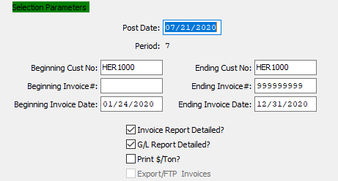

### Posting Invoices

The posting process for invoices has been optimized for reduced file locking by consolidating all invoicing together, and then updating the Finished Good items, customers, General Ledger accounts at one time. It will only update them once for the entire run rather than updating them for each invoice line.

This improves the performance of the posting process and reduces the file locking issues related to invoices posting many invoices for the same customer or item.

Only invoices that appear on the register will be posted and only if the user indicates they want to post them.

#### Posting Summary

The posting will create a posting summary file (In comma separated value format) of the posting results that will match the invoice register for analysis and record keeping. The location of this file is defined by the ***“N”-“K”-“1”*** = Use New Invoice Post as the character value.